Business Practice Manual for

Rules of Conduct Administration

Version 8
Last Revised: January 6, 2025
APPROVAL HISTORY
Approval Date: March 13, 2009
Effective Date: March 13, 2009
BPM Owner: Tricia Johnstone
BPM Owner’s Title: Director, Operational Readiness

TABLE OF CONTENTS
1. INTRODUCTION 4
1.1 Purpose of California ISO Business Practice Manuals 4
1.2 Purpose of this Business Practice Manual 4
1.3 References 5
1.4 Acronyms & Specialized Terms 5
2. OVERVIEW OF RULES OF CONDUCT 6
2.1 Rules of Conduct Summary 6
2.2 Summary of Behavior Subject to Sanction 7
3. CAISO ADMINISTRATION PROCEDURES FOR RULES OF CONDUCT 8
3.1 Overview 8
3.2 Monitoring & Preliminary Investigation 9
3.2.1 Referrals to FERC 11
3.2.2 Notifying DMM of Potential Market Violations 11
3.3 Investigation 11
3.3.1 Conducting Investigation 12
3.3.2 Notice of Review 13
3.3.3 Information Requests 14
3.3.4 Time Limitation 14
3.3.5 Results of Review 15
3.4 Sanction Administration 15
3.4.1 Determination of Sanctions 16
3.4.2 Notification of Affected Parties 17
3.4.3 Settlement 17
3.4.4 Disposition of Sanction Proceeds 20
3.5 Record Keeping 22
4. REVISION HISTORY 23

LISTS OF EXHIBITS:
Exhibit 3-1: Overview of Rules of Conduct Process 9
Exhibit 3-2: Monitoring & Preliminary Investigation Process 10
Exhibit 3-3: Investigation Process 11
Exhibit 3-4: Sanction Administration Process 16

INTRODUCTION
Welcome to CAISO BPM for Rules of Conduct Administration. In this Introduction you will find the following information:
- The purpose of CAISO BPMs
- What you can expect from this CAISO BPM
- Other CAISO BPMs or documents that provide related or additional information

Purpose of California ISO Business Practice Manuals
The Business Practice Manuals (BPMs) developed by CAISO are intended to contain implementation detail, consistent with and supported by the CAISO Tariff, including: instructions, rules, procedures, examples, and guidelines for the administration, operation, planning, and accounting requirements of CAISO and the Markets. Each Business Practice Manual is posted in the BPM Library at: http://bpmcm.caiso.com/Pages/BPMLibrary.aspx. Updates to all BPMs are managed in accordance with the change management procedures included in the BPM for Change Management.

Purpose of this Business Practice Manual
The CAISO BPM for Rules of Conduct Administration describes how CAISO administers the Rules of Conduct for participating in CAISO Markets.

Although this BPM is primarily concerned with the Rules of Conduct, which can be found in Section 37 of the CAISO Tariff, there is some overlap with other BPMs. Where appropriate, the reader is directed to the other BPMs for additional information.

The provisions of this BPM are intended to be consistent with the CAISO Tariff. If the provisions of this BPM nevertheless conflict with the CAISO Tariff, the CAISO is bound to operate in accordance with the CAISO Tariff. Any provision of the CAISO Tariff that may have been summarized or repeated in this BPM is only to aid understanding. Even though every effort will be made by CAISO to update the information contained in this BPM and to notify Market Participants of changes, it is the responsibility of each Market Participant to ensure that he or she is using the most recent version of this BPM and to comply with all applicable provision of the CAISO Tariff.
A reference in this BPM to the CAISO Tariff, a given agreement, any other BPM or instrument, is intended to refer to the CAISO Tariff, that agreement, BPM or instrument as modified, amended, supplemented or restated.

The captions and headings in this BPM are intended solely to facilitate reference and not to have any bearing on the meaning of any of the terms and conditions of this BPM.

References
Other reference information related to this BPM includes:
- Other CAISO BPMs.
- CAISO Tariff, in particular Section 37, Rules of Conduct.
- Policy Statement on Market Monitoring Units, FERC, Docket PL05-1-000, 5/27/2005.
- FERC Code of Federal Regulations Market Behavior Rules, 18 C.F.R. § 35.37, and Prohibition of Electric Energy Market Manipulation, 18 C.F.R. § 1c.2.
- Order 719, FERC, Docket ER09-1048, 10/17/2008.
- FERC, Docket ER24-872, 1/12/2024, effective 4/1/2024.
- FERC, Docket ER25-54, 10/8/2024, effective 1/6/2025.

Acronyms & Specialized Terms
The definition of acronyms and words beginning with capitalized letters are given in the BPM for Definitions & Acronyms.

OVERVIEW OF RULES OF CONDUCT
Welcome to the Overview of Rules of Conduct section of the CAISO BPM for Rules of Conduct Administration. In this section you will find the following information:
- Summary of the CAISO Tariff Rules of Conduct.
- Summary of behavior that is subject to Sanction under the CAISO Tariff Rules of Conduct (CAISO Tariff Section 37).

Rules of Conduct Summary
CAISO Tariff Section 37.1, Objectives Definition and Scope

The Rules of Conduct, which can be found in the CAISO Tariff Section 37, are intended to provide fair notice to Market Participants of the conduct expected of them, to provide an environment in which all parties may participate on a fair and equal basis, to redress instances of market manipulation and other instances of anticompetitive behavior, and thereby to foster confidence of Market Participants, ratepayers and the general public in the proper functioning of the CAISO Markets.

At a high level, the Rules of Conduct are as follows:
- “Comply with Operating Instructions” (CAISO Tariff Section 37.2).
- “Submit Feasible Bids and Submissions to Self-Provide” (CAISO Tariff Section 37.3).
- “Comply with Availability Reporting Requirements” (CAISO Tariff Section 37.4).
- “Provide Factually Accurate Information” (CAISO Tariff Section 37.5).
- “Provide Information Required by CAISO Tariff” (CAISO Tariff Section 37.6).
- “Provide Monitoring Data” (CAISO Tariff Section 37.7).

Summary of Behavior Subject to Sanction
As a general rule, the CAISO investigates and administers associated Sanctions for violations of the Rules of Conduct that can be objectively determined and for which pre-determined Sanctions are established in the CAISO Tariff. Conduct that potentially violates the Rules of Conduct which CAISO administers are listed in “Administration” (CAISO Tariff Section 37.1.5) and include failures to provide accurate and timely SQMD, failure to comply with generator availability reporting requirements, etc. Where the particular circumstances of a potential violation preclude an objective determination that a violation occurred, the CAISO refers the matter to the Federal Energy Regulatory Commission (FERC). Conduct that potentially violates the Rules of Conduct which FERC administers include the failure to comply with orders, the failure to start and bring on line a Resource Adequacy Resource, the failure to undertake operating and maintenance procedures necessary to avoid a major Outage, and the failure to submit bids from resources that are reasonably expected to be capable of performing at the levels specified in the bids. These events are referred to FERC’s Office of Enforcement by the CAISO’s Department of Market Monitoring (DMM). DMM may also refer potential violations of other FERC rules and regulations to FERC’s Office of Enforcement.

Ultimate authority to determine whether a particular practice violates the CAISO Tariff rests with FERC. Market Participants may contact staff of FERC’s Office of Enforcement directly via the FERC hotline to inquire about staffs’ views regarding the permissibility of specific behavior (https://www.ferc.gov/enforcement-legal/enforcement/enforcement-hotline/contact-hotline-staff-anonymously). Market Participants may also request a no-action letter from FERC regarding whether proposed conduct violates the CAISO Tariff or other applicable rules or regulations (https://www.ferc.gov/no-action-letters-0).

This BPM describes the procedures that CAISO uses to administer the Rules of Conduct, including:
- Monitoring and review of behavior
- Referrals to FERC
- Conducting investigations
- Administering Sanctions
- Record keeping
These processes are described in more detail in the following sections

CAISO ADMINISTRATION PROCEDURES FOR RULES OF CONDUCT
Welcome to the CAISO Administration Procedures for Rules of Conduct section of the CAISO BPM for Rules of Conduct Administration. In this section you will find the following information:
- How CAISO carries out its Rules of Conduct monitoring and conducts preliminary investigations.
- How CAISO investigates potential Rules of Conduct violations with Scheduling Coordinators and, as applicable, Market Participants.
- How CAISO administers Sanctions for Rules of Conduct Violations.

Overview
CAISO Tariff Section 37.8, Process for Investigation and Enforcement

FERC orders require the CAISO to independently and objectively administer the Rules of Conduct. Various CAISO business units monitor Market Participants’ behavior in the CAISO Markets and in real-time operations. When a potential violation is discovered, the investigation process is conducted in accordance with tariff requirements that include notifying Market Participants of any investigation and providing Market Participants an opportunity to present evidence and issues of fact regarding the matter being investigated.

Exhibit 3-1 shows an overview of the process to enforce the Rules of Conduct. The process comprises three steps:
- Monitoring, Preliminary Investigation, and Possible Referral to FERC – During this stage, various CAISO business units monitor CAISO markets and operational activities. Based on this monitoring effort, a preliminary investigation of potential Rules of Conduct violations is conducted. At this stage, DMM will be informed if the potential violation is of a Rule of Conduct that FERC, rather than the CAISO, is responsible for administering. The details of these activities are described in Section 3.2.
- Investigation and Market Participant Notification – In the event that monitoring and preliminary investigation activities identify that an objectively verifiable violation of the Rules of Conduct may have occurred, the CAISO investigates the matter, including notifying the Market Participant and providing the Market Participant the opportunity to provide relevant information, as described in Section 3.3.
- Sanction Administration – In the event that the investigation reveals that a Rules of Conduct violation occurred, the CAISO determines the tariff-required Sanction. Financial penalties are invoiced to the applicable Scheduling Coordinator through the Settlement process. Market Participants have the right to appeal penalties to FERC, as described in Section 3.2, Monitoring and Preliminary Investigation.
Exhibit 3-1 below summarizes the process that the CAISO follows to identify and investigate potential Rules of Conduct violations and administer any required Sanctions. These processes are described in more detail in the following sections.

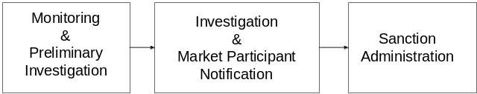Exhibit 3-1: Overview of Rules of Conduct Process

Monitoring & Preliminary Investigation
The CAISO continuously monitors for potential Rules of Conduct violations. A complete and detailed description of its monitoring practices is outside the scope of this BPM; however, at a high-level, the monitoring practices consist of the following:
- Reviews in response to referrals from other CAISO business units responsible for Grid and Market operations.
- Computer-automated review of market data.
- Self-reports of conduct that potentially violates the Rules of Conduct
Exhibit 3-2: Monitoring & Preliminary Investigation Process
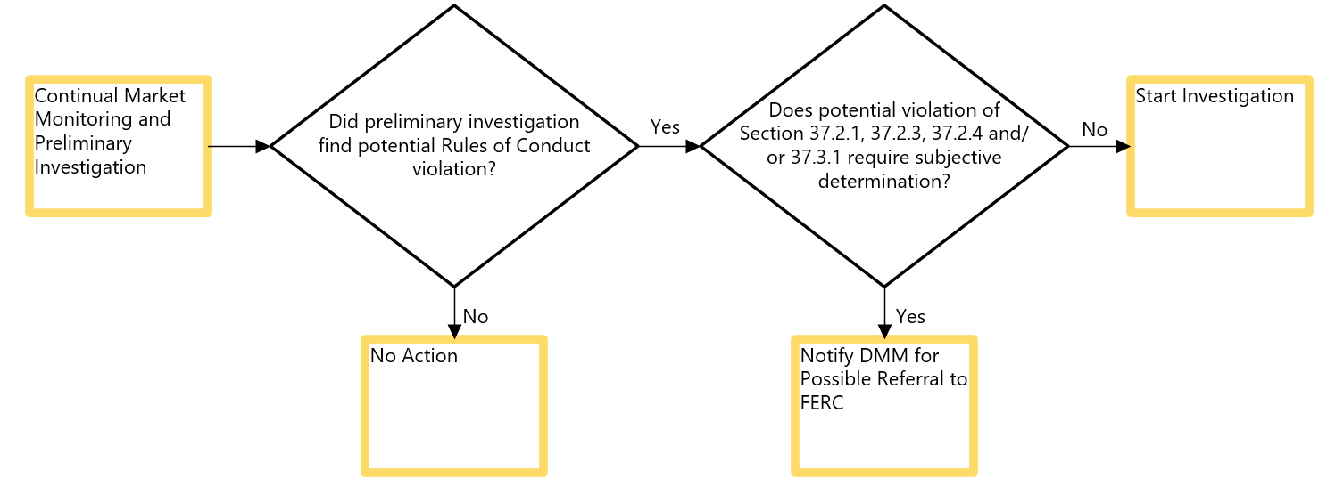

When a potential Rules of Conduct violation is identified, through either routine monitoring or referral, the CAISO initially reviews available information to determine if there is a reasonable potential that a violation occurred, making further investigation appropriate. In the course of collecting information, the CAISO may contact any Market Participant that is the subject of this preliminary investigation, except in cases such as potential violations of routine information submittal requirements, when individually contacting each Market Participant prior to sending a notice of investigation would not be practical.

Based on this preliminary investigation, the CAISO proceeds with one of three actions:
- Initiates an investigation, if the results of the preliminary investigation reveal that an enforceable Rules of Conduct violation may have occurred.
- Notifies DMM (as detailed in section 3.2.2) if the conduct involves a potential violation of CAISO Tariff Sections 37.2.1, 37.2.3, 37.2.4 or 37.3.1. DMM then potentially refers the matter to FERC’s Office of Enforcement pursuant to DMM’s general obligation to refer Market Violations to the Office of Enforcement.
- No further action taken, if the preliminary investigation indicates that an enforceable Rules of Conduct violation did not occur.

Referrals to FERC
Based on the results of its preliminary investigation, if the CAISO discovers that the circumstances preclude the objective determination of a Rules of Conduct violation, it may refer the matter to FERC through DMM.

Notifying DMM of Potential Market Violations
Based on the results of its preliminary investigation, if CAISO business units discover a potential violation of Sections 37.2.1, 37.2.3, 37.2.4 or 37.3.1, DMM will be notified. Under Section 11.1 of Appendix P, DMM has a general obligation to refer to FERC suspected Market Violations, with the exception of Rules of Conduct violations that carry specified Sanctions administered by the CAISO. Where a CAISO business unit notifies DMM of a potential violation of Sections 37.2.1, 37.2.3, 37.2.4 or 37.3.1, DMM will refer the matter to FERC if DMM determines, in its sole discretion, that there is sufficient credible information to warrant further investigation by the Office of Enforcement.

Investigation
If the preliminary investigation by the CAISO reveals that an objectively verifiable violation of the Rules of Conduct may have occurred, the CAISO more formally investigates the matter pursuant to the process described in this section and CAISO Tariff Section 37.8.3. Exhibit 3-3 describes the process used by the CAISO to investigate potential Rules of Conduct violations.
Exhibit 3-3: Investigation Process
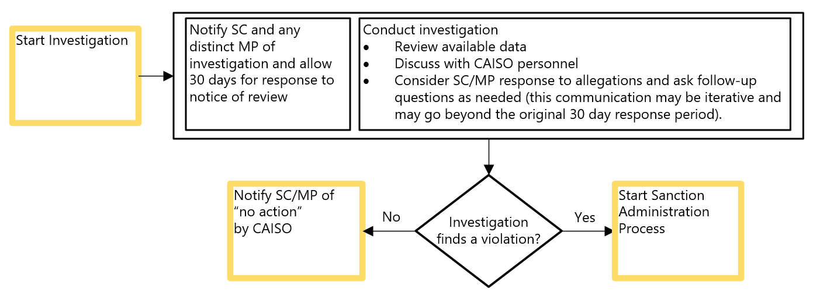

When the CAISO begins an investigation into a potential Rules of Conduct violation, it reviews applicable information, notifies the relevant Market Participants of the investigation and provides an opportunity for Market Participants to respond to the allegations. Market Participants have 30 calendar days to respond to the allegations before the CAISO determines the results of the investigation including whether a Sanction is required.

On completion of an investigation, the CAISO notifies relevant Market Participants of the results of its investigation and of any applicable Sanctions. If the investigation does not identify a violation, the CAISO informs relevant Market Participants that no action is being taken by the CAISO.

If the investigation concludes that a Rule of Conduct was violated and that a Sanction is required by the Tariff, the results of its investigation state that the Market Participant whose conduct gave rise to the Sanction may obtain immediate review of the CAISO’s determination by directly appealing to FERC within 30 days from the date of the results of review notice as described in Section 37.8.10 of the CAISO Tariff. If the Market Participant appeals with FERC within 30 days and communicates the FERC Docket number to the CAISO, any financial penalty associated with the Sanction is tolled pending FERC’s ruling on the appeal. Otherwise, the CAISO proceeds to administer Sanctions as described in Section 3.4.

Conducting Investigation
CAISO Tariff 37.8.3, Investigation

When investigating potential Rules of Conduct violations, the CAISO seeks available facts, data, and other relevant information. This typically includes a review of the available data relevant to the matter including logs and electronic forms of available information – such as market data, discussions with relevant internal CAISO personnel and applicable Market Participants, and reviews of pertinent tariff provisions. The CAISO notifies applicable Market Participants and provides an opportunity for Market Participants to provide any relevant information, such as information that demonstrates that no violation occurred. In addition, the CAISO may require Market Participants to provide specific requested information to be used in its investigation, as described in Section 3.3.3, below. The CAISO maintains a record of the investigation including relevant information.

Notice of Review
CAISO Tariff 37.8.4, Notice of Review

The CAISO makes a notification to Market Participants when it initiates an investigation. This notice of review states that the CAISO is undertaking an investigation of a potential Rules of Conduct violation, describes the allegation in sufficient detail to allow for a response by a Market Participant that is the subject of an investigation, and that the CAISO will consider any relevant information provided by the Market Participant within 30 calendar days.

The CAISO generally makes this notification to the applicable Scheduling Coordinator. The CAISO also notifies any Market Participants that may be the subject of an investigation if: (1) the Market Participant is a separate entity from the Scheduling Coordinator that represents it with the CAISO; (2) the CAISO is able to identify the separate role of the Market Participant in the potential Rules of Conduct violation; and (3) the CAISO has access to the identity of, and contact information for, a Market Participant. Market Participants meeting these requirements likely have an existing contractual relationship with the CAISO as described in CAISO Tariff Section 37.8.4.

The CAISO makes this notification through email to the Scheduling Coordinator’s appropriate business contact, if known, and otherwise to the primary contact representative of the Scheduling Coordinator or separate Market Participant as listed in the relevant contract agreements with the CAISO. Scheduling Coordinators may make a written request that the CAISO use a different contact, for matters under CAISO Tariff Section 37, than the person who is listed on the contract agreements with the CAISO.

Information Requests
CAISO Tariff 37.6.2, Investigation Information
CAISO Tariff 37.6.4, Review by FERC

The CAISO may request specific information that it requires as part of its investigation from Market Participants. CAISO Tariff Section 37.6.2 specifies that Market Participants are subject to financial penalty if they do not provide such requested information within the timeline specified by the CAISO. Market Participants that object to providing this information may – no later than the due date for the information – seek FERC’s immediate review of the obligation, pursuant to CAISO Tariff Section 37.6.4. The obligation to respond to the CAISO is tolled pending a decision from FERC.

Time Limitation
CAISO Tariff 37.10.1, Time Limitation

Sanctions may only be assessed if the CAISO issues a notice of review within 90 calendar days of the CAISO’s discovery of the events subject to investigation. The CAISO may assess Sanctions under CAISO Tariff Section 37 up to one year after discovery of the events constituting a violation of the Rules of Conduct, but no later than three years after the date of the violation. The CAISO’s discovery date for Rules of Conduct violations is recorded as the date that the CAISO business unit responsible for the Rule of Conduct in question became aware of the violation. That awareness is established either through business unit review (manual or automated) of market data or via a self-report.

Results of Review
CAISO Tariff 37.8.5, Results of Review

At the conclusion of its investigations, the CAISO determines whether a violation occurred or not and notifies the Market Participant in its results of review notice. If the CAISO determines that no violation occurred, the results of review states “no violation” and that the CAISO considers the matter closed. If a violation did occur, the results of review states that the investigation found that a violation did occur and describes any applicable Sanction required by the CAISO Tariff.

Sanction Administration
CAISO Tariff 37.8.6, Assessment of Sanctions
CAISO Tariff 37.9, Administration of Sanctions

Where the CAISO has determined that a violation occurred and where that violation requires a Sanction, the CAISO administers the Sanction through a process that includes the following steps:
- Determination of Sanctions (Section 3.4.1).
- Notification of Affected Parties (Section 3.4.2).
- Settlement of Penalties (Section 3.4.3.1).
- Market Participant Appeals to FERC (Section 3.4.3.2).

Exhibit 3-4 describes the process the CAISO uses to administer Sanctions. The CAISO first determines the appropriate Sanction in accordance with the CAISO Tariff and notifies the Scheduling Coordinator/Market Participant of the Sanction along with its results of review. The Market Participant has the right to directly appeal Rules of Conduct Sanctions imposed by the CAISO to FERC. Financial penalties which are not appealed to FERC within 30 days of the results of review notice are subsequently invoiced through the CAISO Settlement Process, but no sooner than 30 days from the results of review notice. Further details of this process are provided in the following sections.

Exhibit 3-4: Sanction Administration Process
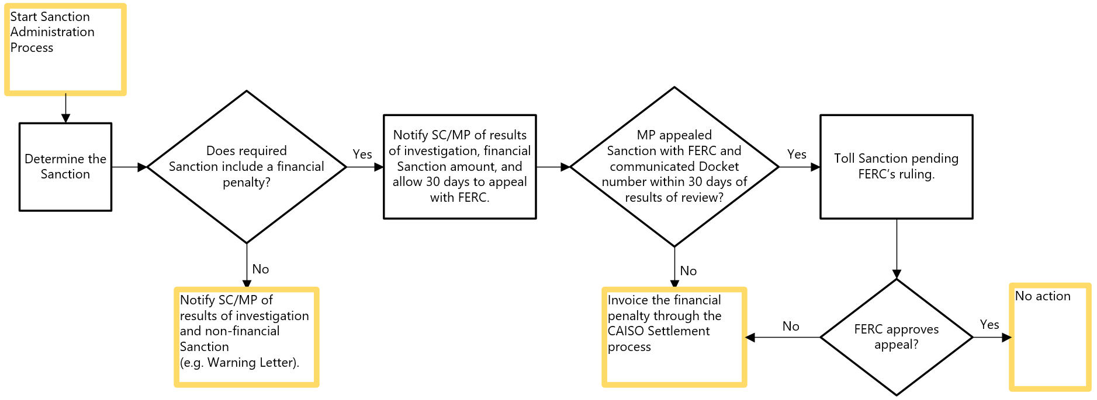

Determination of Sanctions
CAISO Tariff Section 37.9, Administration of Sanctions

The CAISO determines the appropriate Sanction for a Rules of Conduct violation pursuant to the criteria specified in CAISO Tariff 37. The criteria differ for violations of the different Rules of Conduct. By way of example, the Sanction depends on variables such as the number of previous violations or the number of days that information is late. For certain violations, penalties are increased if the violation occurs during a System Emergency, as described below. Sanctions may include a financial penalty or a warning letter.

Financial penalty amounts are tripled for violations of CAISO Tariff Section 37.4 (Comply with Availability Reporting Requirements) if the violation occurred during a System Emergency. The CAISO determines that a System Emergency existed when a Rules of Conduct violation occurred within the time period listed as part of a System Emergency or Transmission Emergency notice issued by the CAISO.

Violations of 37.5.2, Accurate and Timely SQMD, may involve a market adjustment, which is a charge separate from any financial penalty amount that approximates the value of inaccurate, late, or missing Meter Data (See CAISO Tariff Sections 37.5.2.2.4). Note that not every violation of section 37.5.2 necessarily triggers a market adjustment.

When a separate Market Participant, distinct from the Scheduling Coordinator representing the Market Participant, is solely responsible for a Rules of Conduct violation, the applicable Sanction specified in CAISO Tariff Section 37 is levied against the responsible Market Participant through the Scheduling Coordinator. When the CAISO cannot delineate responsibility for a Rules of Conduct violation between a Scheduling Coordinator and a separate Market Participant represented by the Scheduling Coordinator, the applicable Sanction is levied against the Scheduling Coordinator and the Market Participant jointly through the Scheduling Coordinator.

Notification of Affected Parties
CAISO Tariff Section 37.9, Administration of Sanctions

As stated in Section 3.3.5, at the conclusion of its investigation the CAISO determines whether a violation occurred and communicates the results of its review including any applicable Sanction to the responsible Scheduling Coordinator and all Market Participants the Scheduling Coordinator represents that are liable for the penalty. If the Sanction is a financial penalty, the CAISO also provides the following information:
- Description of the penalty, including identity of the Market Participant(s) that committed the violation and the amount of the penalty.
- Specification of whether penalty is modified pursuant to CAISO Tariff Section 37.4.4.

Settlement
Penalties for Rules of Conduct violations, as well as market adjustments for inaccurate, late, or missing Meter Data, are invoiced through the CAISO Settlement Process and will appear on a Settlement Statement no sooner than 30 days after the CAISO has provided its results of review. Market Participants may appeal penalties assessed by the CAISO to FERC. The CAISO holds the proceeds of penalties collected in a trust account, allocating them after the completion of the calendar year during which they were assessed to Market Participants that have not incurred a penalty during that calendar year under CAISO Tariff Section 37, in proportion to GMC paid per CAISO Tariff Section 37.9.4.
Violations of CAISO Tariff Section 37.5.2, Accurate and Timely SQMD, may include a market adjustment, which is a charge under CAISO Tariff Section 37 to provide an approximate settlement for the value of the inaccurate, late, or missing Meter Data. The market adjustment is calculated based on the MWh value of the inaccurate, late, or missing Meter Data in each hour of the applicable period that was not processed in the CAISO’s regular market settlements process. The market adjustment charge is calculated on an hourly basis. The charge is the product of the applicable MWh value in the hour and the average RTD LMP during the hour, subject to a minimum price for the hour of $10/MWh. Note that the CAISO does not assess a market adjustment when the initial error was to the Scheduling Coordinator’s detriment or if the Scheduling Coordinator, under a single SCID, is the only Scheduling Coordinator in the utility service area during the Meter Data event. The CAISO allocates market adjustment proceeds to Scheduling Coordinators, in proportion to average UFE charges for the corresponding UDC territory during the period of the inaccurate, late, or missing Meter Data. The allocation is included on the Settlement Statements for the same Trading Day that the CAISO includes the market adjustment charge on the Settlement Statement.

Settlement of Penalties
Charges and allocations made pursuant to CAISO Tariff Section 37 are ordinarily made by CAISO once a month, and ordinarily are included as a special adjustment on a Settlement Statement. These charges and allocations appear under the following Settlement Statement Charge Codes (see also related Settlement BPMs):
- CC 1591 CAISO Tariff Section 37 Penalty Charge
- CC 1592 CAISO Tariff Section 37 Penalty Allocation Payment (i.e. end of year allocation of penalty funds, as described in Section 3.4.4)
- CC 1593 CAISO Tariff Section 37 Charge/Allocation for Inaccurate, Late, or Missing Meter Data (i.e. the market adjustment charge, as described in Section 3.4.3.)

As described in Section 3.4.2, the CAISO provides a notification to the applicable Scheduling Coordinator, and any separate Market Participants, before a penalty is included on a Settlement Statement. This notification includes a description of the penalty, including the identity of any separate Market Participants that committed the violation, the amount of the penalty, and specification of any modifications.

The following data related to a charge or allocation appears on Settlement Statements in the appropriate Billing Determinant by Charge Code:
- ATTRIBUTE1 field – Business Associate ID.
- ATTRIBUTE9 field –Pass Through Bill (PTB) ID.
- DATA fieldsINT001 field – Total amount of penalty, market adjustment charge, or allocation.
- PTB_COMMENTS field –
- PENALTY - “RoC ID [unique identification number assigned to the violation] per letter dated [date of letter], Rules of Conduct penalty issued in accordance with CAISO Tariff Section [relevant tariff section included].”
- ALLOCATION – “Distribution of Rules of Conduct penalty proceeds for [penalty year] in accordance with CAISO Tariff 37.9.4 per [mm/dd/yyyy] Market Notice.”

Market Participant Appeals to FERC
CAISO Tariff Section 37.8.10, Review of Determination

Penalties assessed under CAISO Tariff Section 37 may be appealed to FERC as outlined in CAISO Tariff section 37.8.10. If a Scheduling Coordinator or a separate responsible Market Participant desires to appeal the CAISO’s determination that the tariff requires a financial penalty for a particular matter, the applicable Scheduling Coordinator must provide the FERC Docket number for the appeal to the CAISO within the CIDI case for the Rules of Conduct event within 30 days from the results of review notice to qualify for penalty tolling. Additionally, a Scheduling Coordinator that appeals to FERC is requested to direct service of its appeal to the CAISO Legal Department via e-recipient@caiso.com. Serving the Legal Department, however, does not substitute for providing the Docket number in the CIDI case.

If FERC denies an appeal, the CAISO will assess the penalty on a subsequent Settlement Statement, after notice (ordinarily within the CIDI case for the Rules of Conduct event) to the relevant Scheduling Coordinator has been given.

Nonpayment by Market Participant
CAISO Tariff Section 37.9.3.3, Other Responsible Party

Where a party or parties other than the Scheduling Coordinator is responsible for the conduct giving rise to a penalty charge, and where the Scheduling Coordinator bears no responsibility for the conduct, such other party or parties are ultimately liable for the penalty. If the Scheduling Coordinator is unable through reasonable efforts to obtain payment from a separate Market Participant, the Scheduling Coordinator should notify the CAISO. If the CAISO finds that the separate party (or parties) is solely responsible for the penalty, then the Scheduling Coordinator should dispute the Settlement Statement that includes the penalty. In the event of such a dispute, the CAISO notifies FERC and reverses the charge on a subsequent Settlement Statement. The CAISO may refuse to offer further service to any responsible party that fails to pay a penalty by providing notice to the relevant Scheduling Coordinator – in such case the relevant Scheduling Coordinator will be responsible for any subsequent penalties assessed on account of such responsible party.

Disposition of Sanction Proceeds
CAISO Tariff Section 37.9.4, Disposition of Proceeds

Payments received for Rules of Conduct penalties are credited to an interest bearing trust account where they are held until allocated. CAISO distributes these funds to eligible Market Participants, through Scheduling Coordinators. Ineligible Market Participants are generally those Market Participants that were assessed a financial penalty during the calendar year, and are described in detail in CAISO Tariff Section 37.9.4.

The penalty funds are distributed by CAISO as follows:
- After the end of each calendar year, each Scheduling Coordinator that is an ineligible Market Participant or that represented an ineligible Market Participant during that calendar year will identify the amount of GMC paid by each Market Participant that the Scheduling Coordinator represented during that year and the GMC paid by the Scheduling Coordinator itself for services provided on its own behalf. The total amount assigned to all Market Participants shall equal the total GMC paid by that Scheduling Coordinator.
- The CAISO calculates the payment due each Scheduling Coordinator as a pro-rata share of the total amount in the trust account determined by the ratio of the GMC paid by the Scheduling Coordinator on behalf of eligible Market Participants to the total GMC paid by all Scheduling Coordinators on behalf of eligible Market Participants. The payment due to each Scheduling Coordinator shall not exceed the GMC actually paid by all eligible Market Participants represented by that Scheduling Coordinator.
- The CAISO includes the payment on Settlement Statements, as Charge Code 1592. Each Scheduling Coordinator is responsible for distributing payments to the eligible Market Participants it represents in accordance with the FERC approved determination of eligible Market Participants and their respective shares of the trust account proceeds.
- After allocating the penalty proceeds, the CAISO posts an informational report to the CAISO Website providing information about the financial Sanctions assessed for the calendar year, including the number of violations and total financial Sanctions assessed for each category of violation, and issues a Market Notice informing Scheduling Coordinators and Market Participants of the availability of the report.

A simplified example of the penalty distribution methodology, assuming $1,000 in penalties were collected over the calendar year, is as follows:
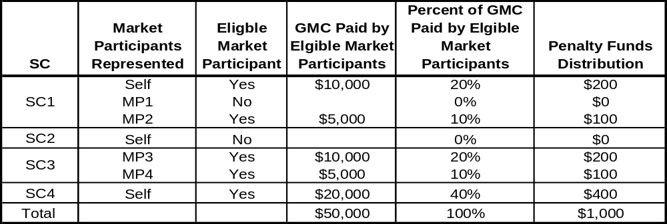

Record Keeping
CAISO Tariff Section 37.8.9, Record of Investigation

The CAISO retains records of Rules of Conduct investigations per CAISO Tariff Section 37.8.9 and as required by the CAISO Record Retention Policy, The record of investigation includes copies of the notifications issued to Market Participants and all data that the CAISO considered relating to the following issues: a) whether the Rules of Conduct were violated; b) any information that the Market Participant provided to indicate that a violation did or did not occur; and c) whether any separate Market Participant was responsible for the violation.

REVISION HISTORY
Version | PRR | Date | Description
8 | 1600 | 1/6/2025 | Updated in support of the PEDRIT initiative Tariff changes related to the creation of demand response monitoring data penalties, streamlining the Rules of Conduct investigative process, updating the penalty tolling process.
7 | 1555 | 4/1/2024 | Updated Tariff Section reference from 37.11 to 37.5.2.2, and Section 3.4 to support FERC approved Tariff changes related to the Disposition of Proceeds process approved in FERC Docket ER24-872.
6 | 1469 | 2/11/2023 | Updated reference to Tariff Section 37.5.2 to ‘Accurate and Timely Actual SQMD’ to align with CAISO Tariff bucket filing language change.
5 | 474 | 10/04/2011 | Revisions related to the CAISO’s April 20, 2011 Compliance Filing which was made in response to FERC’s Compliance Order of January 2011. FERC issued their order July 5, 2011.
4 | 273 | 8/2/2010 | Revisions related to the CAISO’s February 18, 2010 compliance filing, which was made in response to FERC’s November 19, 2009 Order on Compliance Filing concerning the CAISO’s initial Order 719 compliance filing and PTB updates.
3 | 74 | 11/1/09 | Revisions related to Payment Acceleration. PRR 74
2 | 15 | 5/7/2009 | Revisions to implement CAISO’s April 28, 2009 compliance filing in response to FERC Order 719 regarding market monitoring unit roles.
1 |  | 3/13/2009 | Original version

Provided the CAISO has sufficient objective information to identify and verify the responsibility of such Market Participants.
The calculations for the market adjustment charges and allocations are defined in CAISO Tariff Section 37.5.2.2.4.
Under Section 37.9.3.3, the Scheduling Coordinator also has the option of netting its invoice by the amount of the penalty in question. However, where the CAISO reverses the charge, such netting would not be permitted because the Scheduling Coordinator would then be netting its invoice of a charge that no longer appeared on its invoice.

